DEPLOYMENT USER MANUAL
- Install git in their official website. Use this link to install it: https://git-scm.com/downloads
- Install Docker Desktop in their official website
- Install wsl
- Open Command Prompt and run as administration
- Type wsl – install
- Wait
- Type: wsl --version , for confirmation
- If no output is prompted after typing it, retake the steps provided above.
- If wsl is successfully installed, you should see something like this:
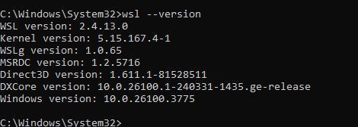
- Clone the dockerized file
- Open Git bash
- Go To Documents in File Explorer
  - Copy The Directory
  - In Git bash type > cd "/c/Users/Windows-username/Documents". Just put the directory between “”, example is, cd "/c/Users/Carlos Miguel/Documents"
  - Clone the repository. Type > git clone -b Environments/Test https://github.com/kylo18/caps-project-approved-code.git
- Open the cloned dockerized file
- navigate to Frontend - Deployment.
- Create an .env file in Frontend - Deployment.
- Right click inside Frontend - Deployment
- click show more options > click new > click text document.
- Rename it to .env
- Make sure that .txt extension is removed and it should only be named “.env” only
- Open the .env file you created and paste this code:
# Frontend base config
VITE_API_BASE_URL=http://”Replace here with localhost:80 or your ip address”/api
- Press Ctrl + s, and close It

- Navigate to Backend - Deployment.
- Create an .env file in Backend - Deployment.
- Right click inside Backend - Deployment > click show more options > click new > click text document.
- Rename it to .env
- Make sure that .txt extension is removed and it should only be named “.env” only
- Open the .env file paste this code:
APP_NAME=Laravel
APP_ENV=local
APP_KEY=base64:fvlguvpXXiHRQN/r735X6Q3Up3uAPBJn7bNxJEhA8DI=
APP_DEBUG=true
APP_URL=http://”Replace with localhost:8000 or your ip address”

LOG_CHANNEL=stack
LOG_DEPRECATIONS_CHANNEL=null
LOG_LEVEL=debug

DB_CONNECTION=mysql
DB_HOST=caps_mysql
DB_PORT=3306
DB_DATABASE=caps_db
DB_USERNAME=kylo
DB_PASSWORD=CAPSwebsite2025

BROADCAST_DRIVER=log
CACHE_DRIVER=file
QUEUE_CONNECTION=sync
SESSION_DRIVER=database
SESSION_LIFETIME=120

FILESYSTEM_DISK=local

# If you're using Laravel Sanctum, set this for CORS
SANCTUM_STATEFUL_DOMAINS=localhost:80

# Optional: If sending emails
MAIL_MAILER=smtp
MAIL_HOST=mailhog
MAIL_PORT=1025
MAIL_USERNAME=null
MAIL_PASSWORD=null
MAIL_ENCRYPTION=null
MAIL_FROM_ADDRESS="hello@example.com"
MAIL_FROM_NAME="${APP_NAME}"
- Make sure that “ your IPv4 Address” should be replaced by your IPv4 address
- Press Ctrl + s, and close It
- Open Docker Desktop
- Open Command Prompt and open it in administrator
- Type cd > location of the cloned file , example C:\Users\Your-Windows-Name\OneDrive\Documents\caps-project-approved-code
- Type docker-compose up -d –build
- Wait for the container to go up
- To confirm it the containers are up, You should see something like this.
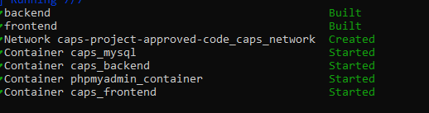
- Type dockers ps. You should see something like this
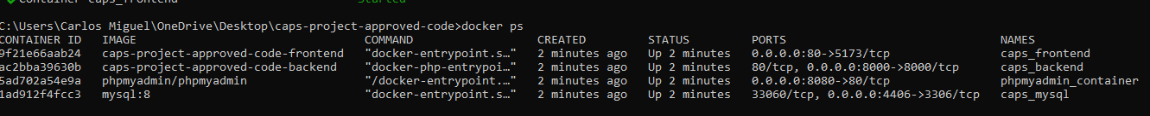
- Go to the backend container
- Type: docker exec -it caps_backend bash
- Type: php artisan migrate
- Type > php artisan db:seed
- If you something like:
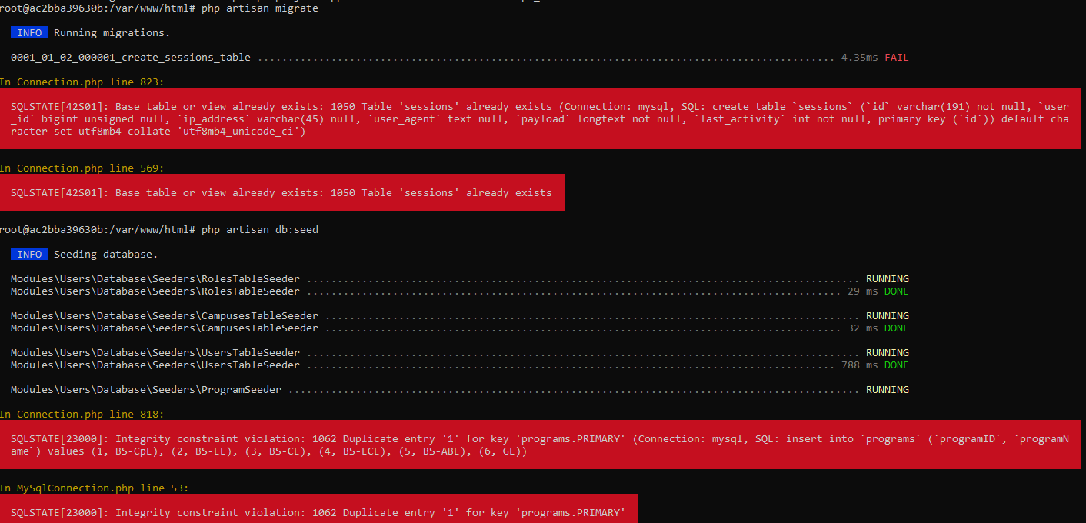
It means the data and database already exists. You can proceed to the next step.

- Type: php artisan storage:link . You should see something like this:
- If you see that the link is already connected, ignore it.
- Type: exit

- Go to your browser and type >https://localhost/ if using http://localhost/ it should redirect to https://localhost/ or type “your Ip address used in .env files”
- The website should work

